NAME: RAJA RAYYAN AMEER
REG. NO.: 23-CP-25
SECTION: ALPHA
SUBJECT: DATABASE MANAGEMENT SYSTEM
DEPARTMENT: COMPUTER ENGINEERING
TEACHER: SIR SHAHID
LAB 14
Task 1: Connect to MongoDB Explanation.
Task 2: Create/Select a Database Explanation.
Task 3: Create a Collection Explanation.
Task 4: Insert a Simple Document Explanation.
Task 5: Insert Document with Embedded Fields Explanation.
Task 6: Insert Multiple Documents Explanation.
Task 7: View All Documents Explanation.
Task 8: Query with Conditions Explanation.
Task 9: Update a Document Explanation.
Task 10: Delete a Document.
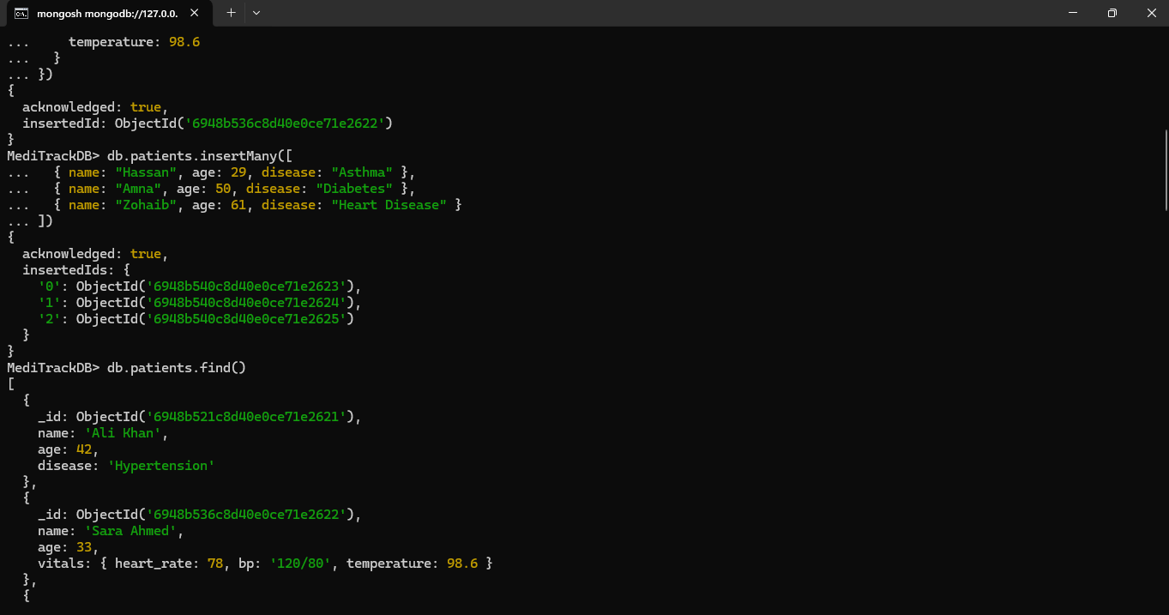
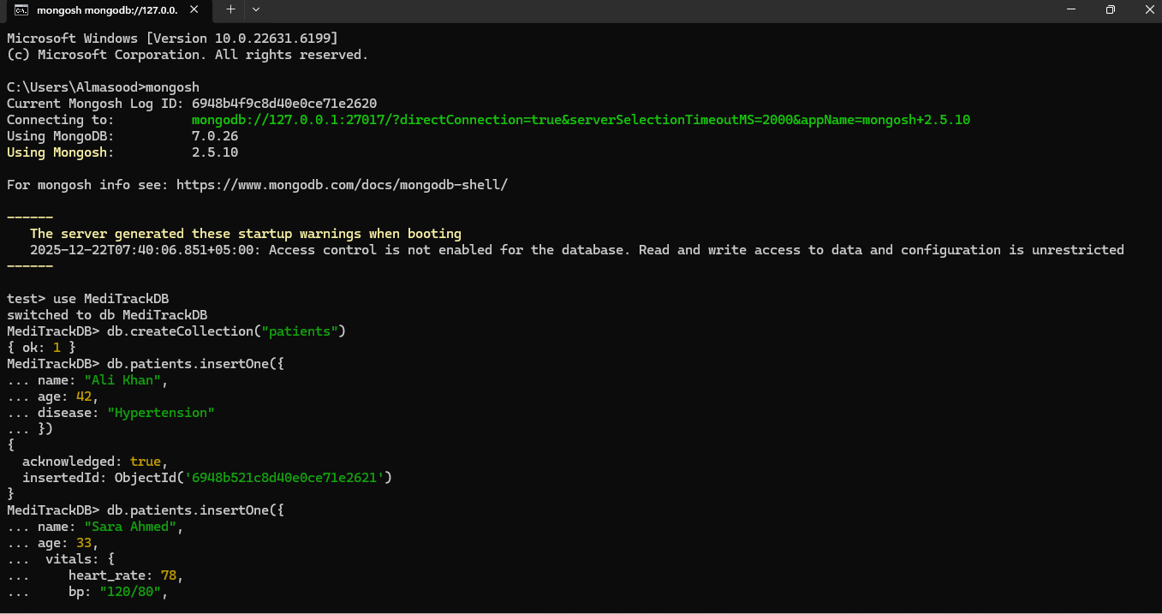

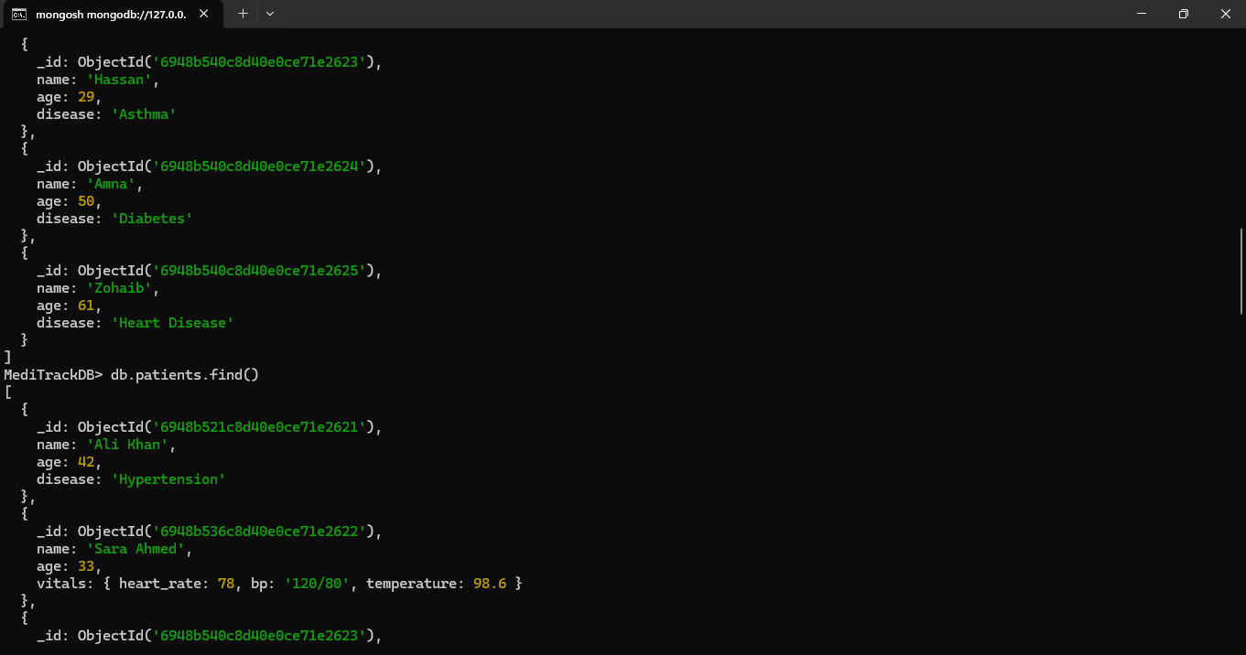
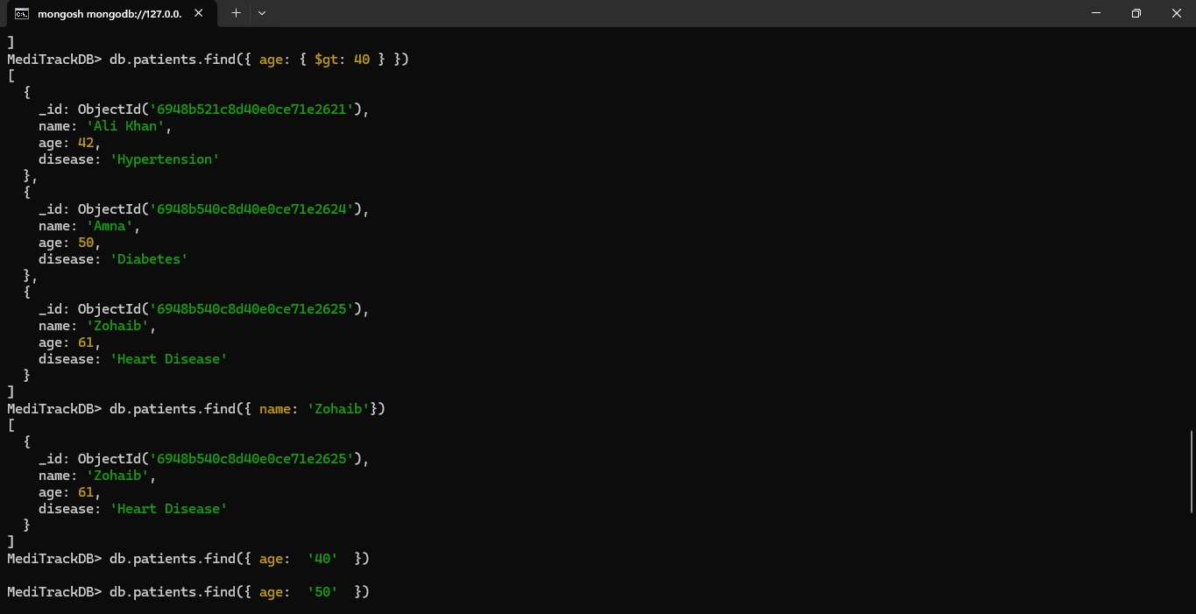
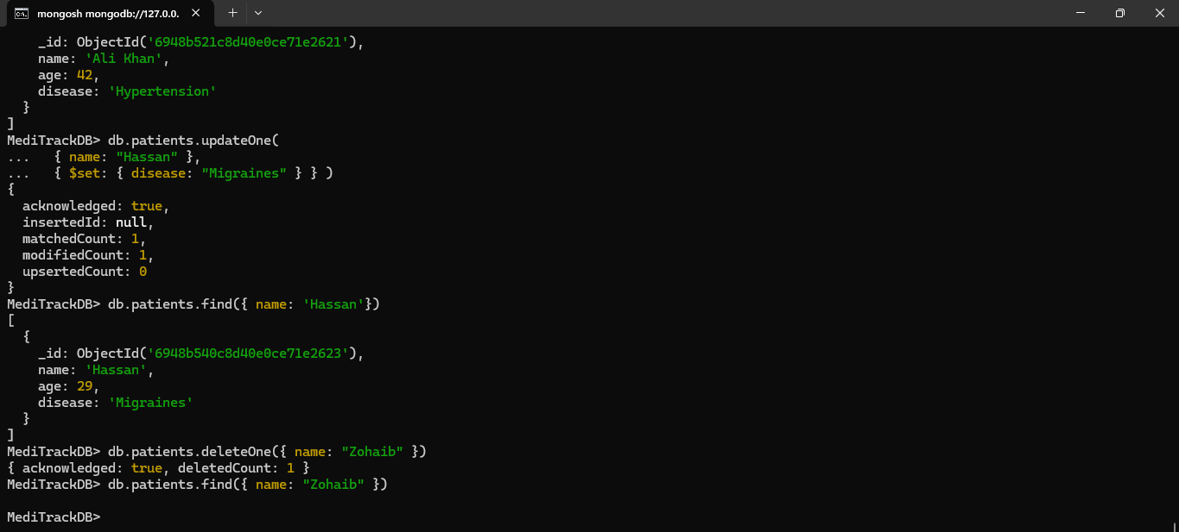
LAB CHALLENGES
- Create a Collection with Embedded and Array Fields:
Create a device_logs collection storing sensor readings like:
Goal: This task aims to help students learn how to design and store complex semi-structured
data using MongoDB’s flexible JSON document model. Students will create a new collection
containing embedded fields and arrays to represent real medical device logs. The goal is to
practice modelling real-world unstructured data without relying on fixed schemas or relational
tables. By completing this task, students will understand how MongoDB handles evolving and
nested data structures.
MediTrackDB> db.device_logs.insertMany([
... {
... device_id: "MD-1001",
... patient: {
... patient_id: "P-001",
... name: "Ali Khan",
... age: 45,
... gender: "Male"
... },
... device_type: "Heart Rate Monitor",
... readings: [
... {
... sensor_type: "Heart Rate",
... value: 78,
... unit: "bpm",
... status: "normal",
... timestamp: new Date("2025-01-10T08:30:00Z")
... },
... {
... sensor_type: "Heart Rate",
... value: 95,
... unit: "bpm",
... status: "elevated",
... timestamp: new Date("2025-01-10T09:00:00Z")
... }
... ],
... battery_level: 85,
... location: "ICU Ward 3",
... created_at: new Date()
... },
...
... {
... device_id: "MD-1002",
... patient: {
... patient_id: "P-002",
... name: "Ayesha Malik",
... age: 32,
... gender: "Female"
... },
... device_type: "Blood Pressure Monitor",
... readings: [
... {
... sensor_type: "Blood Pressure",
... systolic: 120,
... diastolic: 80,
... unit: "mmHg",
... status: "normal",
... timestamp: new Date("2025-01-10T10:15:00Z")
... },
... {
... sensor_type: "Blood Pressure",
... systolic: 145,
... diastolic: 95,
... unit: "mmHg",
... status: "high",
... timestamp: new Date("2025-01-10T11:00:00Z")
... }
... ],
... battery_level: 72,
... location: "General Ward",
... created_at: new Date()
... }
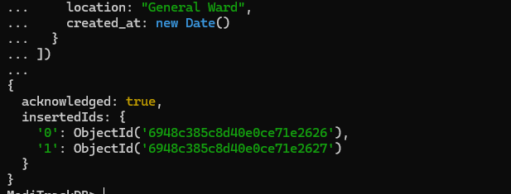
... ])

2. Compare RDBMS vs NoSQL: Create a table comparing 6 differences relevant to MediTrack:
• Schema
• Flexibility
• Scaling
• Joins
• Storage
• Query style
Goal: The purpose of this task is to help students critically compare RDBMS vs NoSQL in a
real application context. Students will analyze the MediTrack scenario and identify where
relational databases work best and where MongoDB provides advantages. The goal is to
develop evaluation skills, understand database selection, and learn how schema flexibility,
scaling, and data variety affect the choice of technology.
Feature | RDBMS (MySQL) | NoSQL (MongoDB)
Schema | Uses a fixed and predefined schema. Any change in structure (such as adding a new sensor type) requires schema modification. | Uses a flexible, schema-less model. New fields and sensor types can be added without changing existing documents.
Flexibility | Less flexible due to strict table structures. Handling changing medical device data is difficult. | Highly flexible. Different devices can store different types of medical readings in the same collection.
Scaling | Primarily supports vertical scaling by upgrading hardware, which can be expensive and limited. | Supports horizontal scaling through sharding, making it suitable for large-scale real-time monitoring systems.
Joins | Provides strong support for joins across multiple tables, which is useful for highly relational data. | Limited join support. Data is usually embedded within documents to reduce the need for joins.
Storage Model | Stores data in structured rows and columns. Medical logs must be split across multiple tables. | Stores data in JSON-like BSON documents, allowing natural representation of nested medical logs.
Query Style | Uses SQL with commands such as SELECT, JOIN, and GROUP BY for data retrieval. | Uses document-based queries and aggregation pipelines optimized for hierarchical data.

3. Update Multiple Nested Fields: Add a new vital inside embedded vitals of Sara Ahmed.
Goal: This task focuses on updating nested JSON structures inside a MongoDB document.
Students will practice modifying embedded objects using update operators such as $set and
$push. The objective is to understand how MongoDB performs partial updates without
rewriting entire documents. Mastering this is essential to operating NoSQL databases
efficiently and accurately.
MediTrackDB> db.patients.updateOne(
... { name: "Sara Ahmed" },
... {
... $set: {
... "vitals.oxygen_level": 97
... }
... }
... )
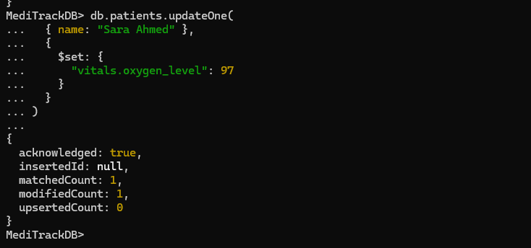
4. Query Using Multiple Condition:
• Find all patients:
o age > 40
o disease ∈ {Diabetes, Heart Disease}
Goal: The primary goal here is to strengthen student understanding of conditional and
compound queries in MongoDB. Students will formulate queries using multiple conditions
such as $gt, $and, and $in, enabling them to perform selective retrieval from document
collections. This reinforces real-world data filtering, analysis, and interpretation skills within a
NoSQL environment.
MediTrackDB> db.patients.find({ age: {$gt:40 },
disease:{$in: ['Diabetes','Heart Disease']}})
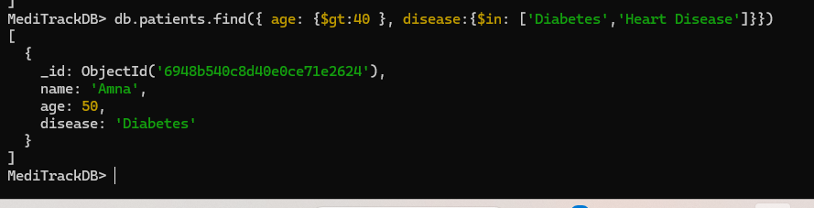
- Design NoSQL Schema for Realtime Monitoring of IoT Stream.
Design JSON for storing per-5 second heart-rate logs.
Goal: This task teaches students how to design an efficient NoSQL schema for high frequency, real-time IoT data. Students will propose a document structure to store continuous sensor readings for a patient, considering issues like document growth, embedding vs referencing, and efficient querying. The goal is to develop schema-design thinking for modern applications where relational models become restrictive.
db.heart_rate_logs.insertOne({
patient_id: "P-002",
device_id: "HRM-7781",
date: "2025-03-15",
minute_window: "10:21",
readings: [
{ time: "10:21:00", heart_rate: 76 },
{ time: "10:21:05", heart_rate: 77 },
{ time: "10:21:10", heart_rate: 79 },
{ time: "10:21:15", heart_rate: 78 },
{ time: "10:21:20", heart_rate: 80 },
{ time: "10:21:25", heart_rate: 82 },
{ time: "10:21:30", heart_rate: 81 },
{ time: "10:21:35", heart_rate: 83 },
{ time: "10:21:40", heart_rate: 84 },
{ time: "10:21:45", heart_rate: 82 },
{ time: "10:21:50", heart_rate: 81 },
{ time: "10:21:55", heart_rate: 80 }
],
avg_hr: 80,
min_hr: 76,
max_hr: 84,
created_at: new Date()
})
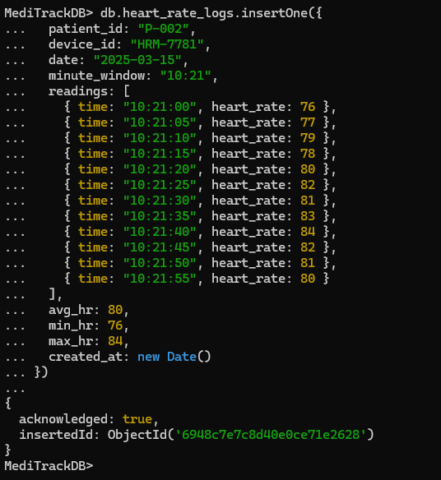
THE END

